West Branch City Council
City Administrator’s Report
8/19/19

Pending Action Items:
(Wastewater Topic)
(Hail Mary Option)
The Baldridge Environmental was awarded an Iowa Energy Center Innovation Grant. It is intended to fund up to six enhanced pilot project around the State of Iowa. Todd Baldridge spoked to me last week with interest to invest his grant funding to enhance the current Pilot Project in West Branch. I spoke with the Iowa Energy Center program coordinator, Amber Buckingham and she anticipates that state will have contracts with Baldridge in the next couple of months. It appears that the Iowa Energy Center are intrigued with the data that Baldridge has been able to produce thus far, and have awarded a very sought after grant to see if these early assertions can be reproduced in other sites. Latest reports high levels of oxygen in the lagoons and indications of debris floating to the surface of the lagoon. This is a good sign because it indicates that the sludge levels are being eaten away and releasing solids that are not digestible by the enzymes. Baldridge Environmental is also conducting pilot studies in Arkansas and the results are proving to very positive outcomes. Again, the goal of this pilot project is to reduce our lagoon sludge and allow our lagoon wastewater process to perform with highest efficiency. Thus, making the ammonia levels more manageable and potentially at levels well within state compliance levels.

(DNR Unfunded Mandated Process)
Meanwhile, V&K is moving forward with SAGR as the City’s treatment option of choice. As the next step in the process the city placed a public notice called an “Antidegradation Alternative Analysis for the City of West Branch Iowa). This gives the public the opportunity to ask questions, express concerns, and/or share comments that will be shared with the Iowa Department of Natural Resources with the final alternatives analysis subject to IDNR review and approval.

(College Street Bridge)
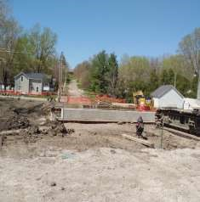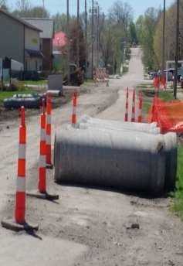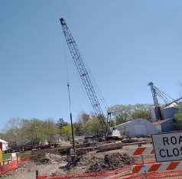

Update see schedule below.

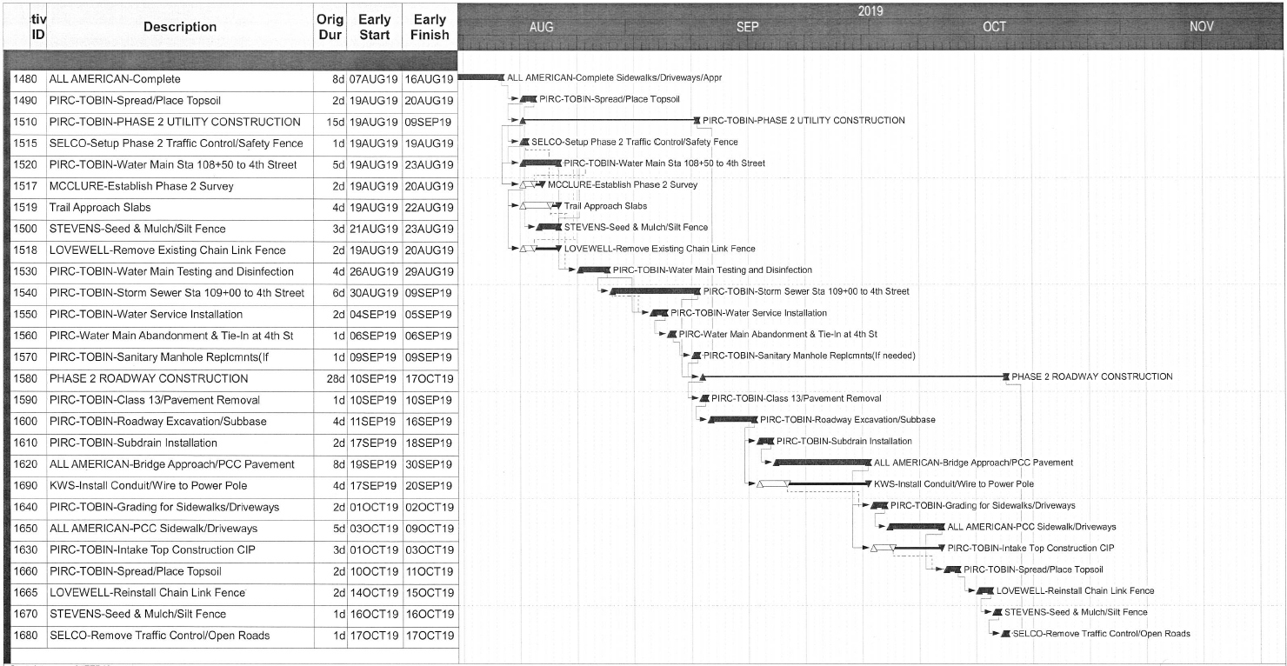

Although, we thank our residents and citizens in advance for the cooperation and patience during the construction process, we are well aware that issues will arise as they tend to do during typical construction projects. If you have any questions, comments, or concerns; please do not hesitate to contact the city’s project engineers.
Dave Schechinger, P.E. | Eric Gould
dschechinger@v-k.net | egould@v-k.net
319-466-1000 | 319-466-1000

(Cubby Park)
There has been some concern regarding the City taking a aggressive position and ordering staff to maintain the park grounds before the project is accepted. I have directed the appropriate staff to begin the process of scheduling park maintenance as a part of our normal rotation of maintenance. I would like to know if the City Council is comfortable with this approach. Understanding the city may ultimately get stuck with this expense.

Report from the Desk of the City Administrator:
- Kudo’s to Matt Goodale and the Public Works Team –
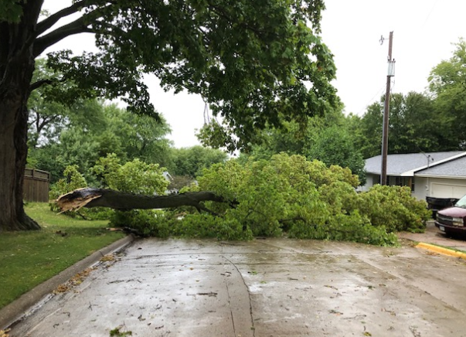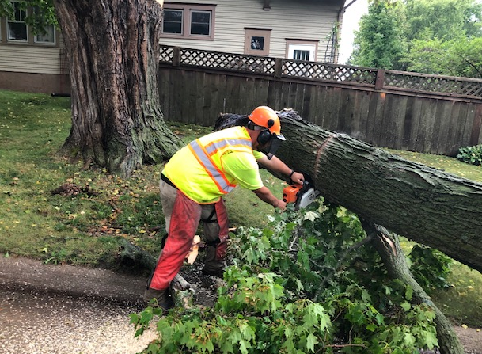

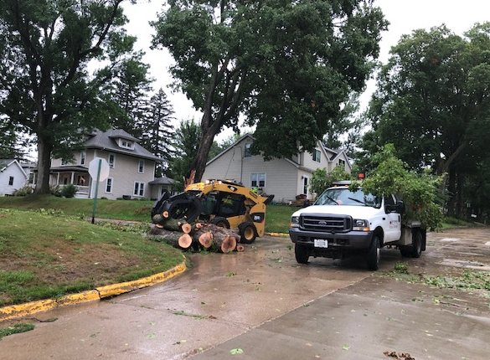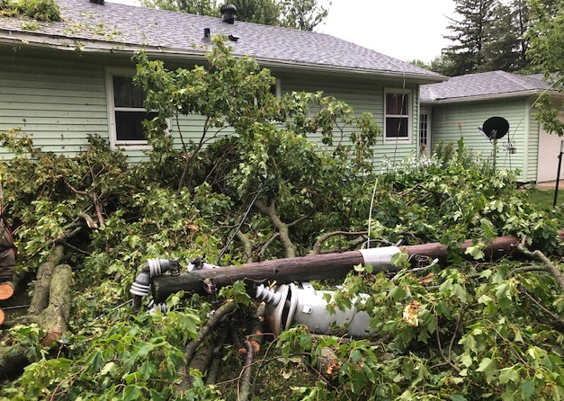

The storm Sunday morning brought as much a 1 1/2 rain and high winds that resulted in down trees on North 6th Street and Oliphant. Despite being on a Sunday Morning and at least one employee on vacation these sites addressed and cleaned up before many of us was out of bed. They took time away from their families and to worship, so that we could. Job Well Done…

- There has been some issues related to the use of Temporary Occupancy Permits. The City has tried to support its builder / Developer community and have been supportive with trying to react to the needs of their clients. However, over the past year we have ran into several examples of where Temporary Occupancy Permits have been abused or non-responsive. Thus, causing neighborhood complaints to rise. For this reason, city development staff have convened and have devised measures that can be implemented without needing to come before City Council for approval; for example streamlining processes to ensure to the appropriate width of sidewalk are being installed. However, there are other areas that will need City Council approval and guidance. For this reason, a Temporary Occupancy Policy will coming before City Council in the near future.

Follow up / Reminder Items:
- Nuisance Abatement Ordinance and New Hearing Committee Board follow-up. We have couple of interested citizens and we expect to have someone presented to Council in the next meeting.

- September 25-27 Iowa League of Cities Conference is in Dubuque. I would like to have as many as possible City Council Members attend. Because the City of Dubuque has capital improvement project that incorporates an outdoor amphitheater that also serves as a basin for rapid flowing water during flood conditions. This concept has been presented to the City Council several times including in the presentation by Impact 7G as a part of the Downtown East Redevelopment project. I have spoken with city officials in Dubuque who would be willing to give me and the city council a tour of this site. This is something that can be arranged while we are attending the Iowa League of Cities Conference.

Month of July
Public Works Weekly Update 7/8-7/12
STREETS
- Daily check of streets. This is done routinely to spot potholes, downed limbs, garbage, water main breaks, sinkholes or other issues before they are found by the general public.
- Yard waste collection.
- Pushed back brush pile twice
- Mowed shoulders
- Went to Shimberg in Cedar Rapids to pick up a floating manhole cover for the College Street Bridge Project. Returned to WB and installed for pour of N Second Street.
- Contacted the resident referenced at the council meeting with the complaint about the tree and bushes. Discussed with him the options and spoke to him about his responsibilities as the homeowner to maintain the right of way. Public works does not typically have to remove small trees or weeds from the right of way due to that being the responsibility of the homeowner to maintain. I looked back and could not find any emails, work orders or texts about this particular issue from last summer as was stated in the email, it may have been discussed at some point but I cannot say definitively either way. The issue on the shrubs in the right of way was discussed in 2011 or 2012 with the homeowner and they did not want them removed at that time. They have been left since then in an effort to meet the wishes of the homeowner at that time. Public works will be removing them and grading the right of way area out for grass. The storm sewer intake referenced has been that condition likely since it was first installed long before I worked for the City and has never been replaced due to the large amount of more pressing storm water issues coupled with small amounts of funds to make those repairs and limited staff time. Likewise the hydrant is an older model with no auxiliary valve and has been that way since installed. I have put it on our list to raise that hydrant and will have our lead water operator get it taken care of when he returns to work.
- Inspected the street pour on Oliphant Street in front of the press box.
WATER
- Daily rounds.
- Backwash filters and clean water plant. This is a weekly task that normally takes 3 to 4 hours spread out throughout the day.
- Charged and flushed new water main at the Northside Addition
- Took bacterial samples from the new main and delivered to the UIHL. Both passed.
- Disconnects and reconnects. Worked with the property owners to get into apartment buildings for both the disconnects and reconnects.
SEWER
- Sampling Tuesday and Wednesday
- Daily rounds.
- Clean lift station screens.
- Wastewater MOR
- Met with homeowner at 140 West Orange Street to look at an issue with a sanitary service, contacted Lynch’s Plumbing to have our main televised on the section their service ties in to

STORM WATER
- Spoke To resident at Greenview on storm water issue. Contacted S&S Flatwork to look at the issue and repair it. They were able to get in quickly to do the repair. Met with a second homeowner also affected by this repair on the phone and then the following morning onsite to give a little better insight into the repairs and what it would look like upon completion.
- Spoke to resident on East Green Street with storm water concern. Met with S&S Flatwork to get a second opinion on it and see if he was interested in digging out their ditch if necessary. It appears to be a minimal issue in the actual ditch although they are getting water in their basement it does not appear to be caused by anything linked to the ditch. We will be cleaning the ditch to the west of this property and see if that helps at all as well as checking elevations of the ditch with our laser and taking the appropriate steps based off our findings.
CEMETERY
- Mowing
- Trimming
PARKS
- Mowing
- Trimming
- Empty trash cans.
- Fill water barrel at dog park
- Check and fill dog waste bags
- Water trees for Cubby Park multiple times to keep them living and in good health until they can be planted.
- Picked up mulch from Menards for trees at Cubby Park
- Disconnected batwing mower and connected auger to tractor for tree planting. Auger appeared to have a slip in the gear box when we began using it so removed it from the tractor and went to Iowa City and rented one for the skid loader. Used and returned same day.
- Planted the remainder of the trees at Cubby Park. Mulched, staked and watered those trees.
- Start-up of irrigation at Cubby Park (with Melissa) to check for issues and to help with the severely dried out fields.
CLASSES/CONFERENCES/TRAINING/MEETINGS
- Weekly safety meeting.
- Met with Lynch’s Excavating to discuss the tie-in to the water main at Cedars Edge for next week. Dug up valves to verify locations and tested for size.
- Took a call from V&K requesting assistance alerting a resident on 2nd Street to the pour that will occur on Wednesday. Contacted homeowner and figured out a game plan for parking and access to her home during and after road construction until curing is complete.
- Corresponded with homeowner after hours pertaining to the alley discussion at the council meeting. She was interested in seeing the prices and would like to discuss further with the council.
- Met with contractor on Ridgeview about sidewalk approaches and appropriate dimensions of all.
- Met with contractor on drainage and wall installation on Sullivan Street.
- Corresponded with DOT on widening project.
OTHER
- Handled 27 locate requests.
- Sprayed the ball diamonds at the high school city maintained areas for weeds as well as several other areas around town again. It rained shortly after spraying last week so we hit these areas again to be sure we have a good kill.
- Tim was off all week for vacation.
- I looked back on my files quickly since it was asked at the council meeting. Since 2012 with the assistance of the Trees Forever/Alliant Energy Branching out Grants the City has planted 415 new trees within the city limits and has received a grant to plant another 41 this fall. So all in all 456 trees planted and paid for by 29,464 grant dollars along with the investment of City Public Works staff time and energy. That does not include trees planted to replace any removed during normal operations, projects or the rest of the Cubby Park plantings. All in all I would estimate closer 525 planted. Those planting projects have included community members, elementary, middle and high school students, as well as school staff.
- Spoke to Mike Jones about the plans for the green space in front of The Down Under for HHTD

Public Works Weekly Update 7/15-7/19
STREETS
- Daily check of streets. This is done routinely to spot potholes, downed limbs, garbage, water main breaks, sinkholes or other issues before they are found by the general public.
- Yard waste collection.
- Pushed back brush pile twice
- Picked up pile of brush, basically a whole large tree from the Days Inn parking lot that someone had dumped there. Not really our issue but the business owner requested it and I decided to help them out.
- Sign locates for Main Street
- Put stop sign and street name signs together to be installed next week.
- Spoke with engineers and All American on College Street bridge project and reopening
- Cleaned up a large limb that had fallen on a sidewalk on West Main Street over the weekend.
WATER
- Daily rounds.
- Backwash filters and clean water plant. This is a weekly task that normally takes 3 to 4 hours spread out throughout the day.
- Hooked up large meter and ran hose for an in ground pool to be filled.
- Ordered meters and other meter supplies for a portion of Pedersen Valley replacements.
- Read meters
SEWER
- Sampling Tuesday and Wednesday
- Daily rounds.
- Clean lift station screens.
- Wastewater MOR
- Wastewater treatment plant visits with engineers and the City Administrator. We visited a Lemna covered lagoon and a SAGR system. An evaluation was completed of each possible option and the results given to council. The top three were SAGR, Lemna and the SBR mechanical plant.
- Arranged for Action Sewer to televise our main and check on any issues that would affect the homeowner on West Orange with sewer back ups. They are planning on next week.
- Discovered tripped blower at the lagoons during morning rounds. Performed our lock out tag out procedure and left off until we could get back to it later in the week. Did a little trouble shooting and inspection on blower. It appeared to be overheating due to high temperatures in the building. Reset motor and put back into service.
STORM WATER
CEMETERY
- Mowing
- Trimming
- Laid out grave for headstone placement
PARKS
- Mowing
- Trimming
- Empty trash cans.
- Fill water barrel at dog park
- Check and fill dog waste bags
- Water trees for Cubby Park two times
- Cleaned up sand bags used to temporarily protect The Down Under form run off. Backfilled along sidewalk and cleaned up. Will remove brick sidewalk, sod, regrade and re-sod after HHTD.
- Brush hog areas at Cubby Park and other areas that have been wet and unable to be mowed until recently.
CLASSES/CONFERENCES/TRAINING/MEETINGS
- Weekly safety meeting.
- Monthly safety meeting. I am having Nevin attend these meetings with Paul so that he can pick up the safety coordination when Paul retires. This could be several years from now but I am trying to be proactive with training employees across many tracts.
- Corresponded with DOT on widening project.
OTHER
- Handled 19 locate requests.
- Tim was off all week for sick leave.
- I was off Wednesday for a vacation day. Flexed time from the previous week.
- Weeded City Office flower beds. Removed mulch and added rock to the beds.

Public Works Weekly Update 7/29-8/3
STREETS
- Daily check of streets. This is done routinely to spot potholes, downed limbs, garbage, water main breaks, sinkholes or other issues before they are found by the general public.
- Yard waste collection.
- Pushed back brush pile once
- Sign locates for Main Street
- Installed new signage
- Met with engineers, Pirc Tobin, Taylor Construction and all American Concrete on timetables for completions and to discuss various stages of the project moving forward
- Street sweeping for downtown and the parade route
- Cold patch potholes
- Cut out concrete, removed base, installed junction box and poured temporary patch in front of the Groom Station. The light pole will be replaced when it is repaired.
- Hand swept downtown sidewalks
- Dug out sink hole on East Main Street near the 4th Street intersection and filled with carry back concrete to the bottom of street level. It appeared to be an old brick cistern that had collapsed and had been filled at one time with sand. It is uncertain why this sink hole showed up at this time but it is not connected to sanitary sewer or storm sewer so I felt confident filling the void with concrete would repair it. We will monitor and take other steps if it reappears.
- Took gravel to the lot around the Fire Station/Police Department, graded parking area and filled potholes
- Took Ranger to get repairs- starter
WATER
- Daily rounds.
- Backwash filters and clean water plant. This is a weekly task that normally takes 3 to 4 hours spread out throughout the day.
- Hooked up large meter and ran hose for an above ground pool to be filled. Ran 250 ft of fire hose
- Spoke with owners of Little Lights and set up to install large hydrant meter for Thursday to water sod. Did not set up meter Friday due to issues with traffic at job site and inaccessibility that would be caused. Spoke to owners again Friday and got hoses, meter and fittings together for their contractor to set up and barricade in order to get their sod watered. Met with Bruce Saturday to go over their plan and get him all of the necessary materials
- Worked on the phosphate pump at the water plant and ended up swapping pumps to keep phosphate running
SEWER
- Sampling Tuesday and Wednesday
- Daily rounds.
- Met with homeowner on the issue with their sewer line. Possibly an issue with the service where it crosses our water main. This main was installed 4 years ago and there is a possibility there was settling that may be causing this issue. Lynch’s will dig up and see if that is the issue.
- Replaced worn belt on blower at lagoons
STORM WATER
- Checked on storm water catch basins installed on College Street Bridge Project that appear to have an issue with installation
CEMETERY
- Mowing
- Trimming
- Mark lot for foundation placement
PARKS
- Mowing
- Trimming
- Empty trash cans.
- Fill water barrel at dog park
- Check and fill dog waste bags
- Water trees for Cubby Park
- Clean floor at Beranek shelter for the weekend
- Clean all bathrooms
CLASSES/CONFERENCES/TRAINING/MEETINGS
- Weekly safety meeting.
OTHER
- Handled 22 locate requests.
- Tim was off all week for sick leave.
- Paul was off one day for bereavement
Preparation for Hoovers Hometown Days
- Built railings and walkway for stage
- Set up detours
- Set up parade layout
- Set up cones for downtown tent install Friday
- Load trailer with cones and barricades
- Lay out barricades for parade route and other street closures
- Picked up generator from Altorpher in Cedar Rapids
- Picked up risers from school for parade stage
- Stage setup at Hoover Presidential Museum
- Wash trucks that will be used in parade
- Got flags, smv signs and zip ties around for Park and Rec to install on golf carts
- Brought golf carts to shop and stored
- Saturday morning in at 2 am to block off parking downtown
- Uncover detour signage
- Set up barricades
- Set trash cans downtown
- Set up umbrella tables
- Bring tables form town hall and set up
- Layout cones on Pedersen street to direct parade traffic to single lane
- Parade line up
- Pulled barricades, cones and caution tape from parade route. Opened all streets and closed down what was necessary for the down town to be shut down
- Checked garbage cans during HHTD
End of downtown festivities Saturday
- Removed barricades
- Removed umbrella tables and stacked to be picked up
- Removed tables from tent and returned to town hall
- Took down portions of the detour for Saturday
- Removed garbage cans and garbage bags
- Picked up trash downtown
- Took down parade stage
- Hauled all to shop
Sunday morning
- Removed remainder of detour
- Picked up remaining barricades
- Pulled road closed signs
- Hauled off rest of trash cans
- Picked up trash from overnight

Thanks, Matt G

